**Experiment No. 7**

**Aim:** Create spinner with strings from the resource folder (res >> value folder). On changing spinner value, change image.

**Program:**

* **Activity.xml :-**

*<?*xml version="1.0" encoding="utf-8"*?>*<RelativeLayout xmlns:android="http://schemas.android.com/apk/res/android"  
 xmlns:app="http://schemas.android.com/apk/res-auto"  
 xmlns:tools="http://schemas.android.com/tools"  
 android:layout_width="match_parent"  
 android:layout_height="match_parent"  
 tools:context=".MainActivity">  
  
 <Spinner  
 android:id="@+id/sp"  
 android:layout_width="150dp"  
 android:layout_height="wrap_content"  
 android:layout_centerHorizontal="true"  
 android:layout_marginTop="100dp"  
 android:entries="@array/spin"  
 android:minHeight="48dp"/>  
  
 <ImageView  
 android:layout_width="270dp"  
 android:layout_height="270dp"  
 android:id="@+id/img"  
 android:layout_marginTop="300dp"  
 android:src="@drawable/supra"  
 android:layout_centerHorizontal="true"  
 />  
  
</RelativeLayout>

* **MainActivity.java :-**

package com.example.spin;  
  
import androidx.appcompat.app.AppCompatActivity;  
  
import android.os.Bundle;  
import android.view.View;  
import android.widget.AdapterView;  
import android.widget.ImageView;  
import android.widget.Spinner;  
  
public class MainActivity extends AppCompatActivity implements AdapterView.OnItemSelectedListener {  
Spinner sp;  
ImageView img;  
  
 @Override  
 protected void onCreate(Bundle savedInstanceState) {  
 super.onCreate(savedInstanceState);  
 setContentView(R.layout.*activity_main*);  
 sp=findViewById(R.id.*sp*);  
 img=findViewById(R.id.*img*);  
 sp.setOnItemSelectedListener(this);  
 }  
  
 @Override  
 public void onItemSelected(AdapterView<?> adapterView, View view, int i, long l) {  
 switch (i){  
 case 0:  
 img.setImageResource(R.drawable.*supra*);  
 break;  
 case 1:  
 img.setImageResource(R.drawable.*porsche*);  
 break;  
 case 2:  
 img.setImageResource(R.drawable.*merc220d*);  
 break;  
 case 3:  
 img.setImageResource(R.drawable.*gwagon*);  
 break;  
 }  
 }  
  
 @Override  
 public void onNothingSelected(AdapterView<?> adapterView) {  
  
 }  
}

* **strings.xml:-**

<resources>  
 <string name="app_name">Spin</string>  
 <string-array name="spin">  
 <item>SUPRA</item>  
 <item>PORSCHE</item>  
 <item>MERC C220D</item>  
 <item>GWAGON</item>  
 </string-array>  
</resources>

**Output:**

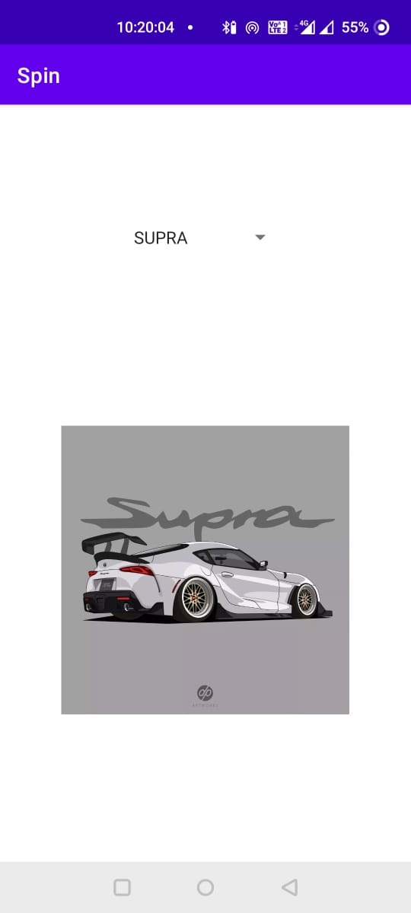 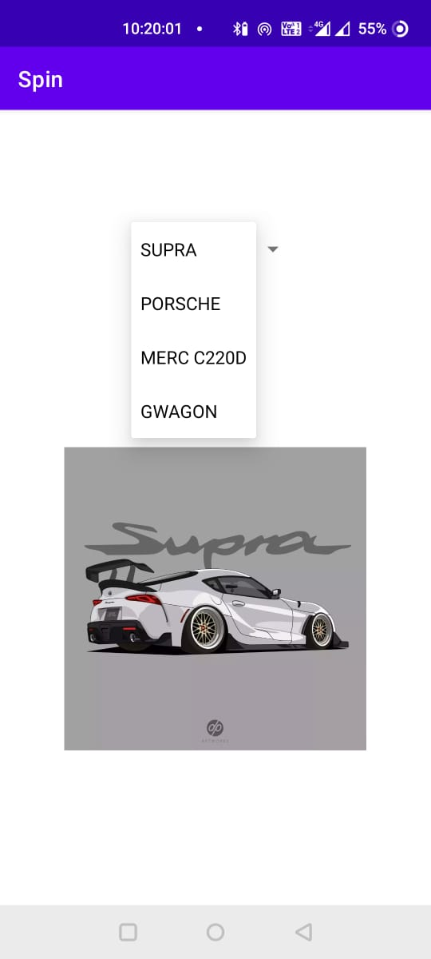

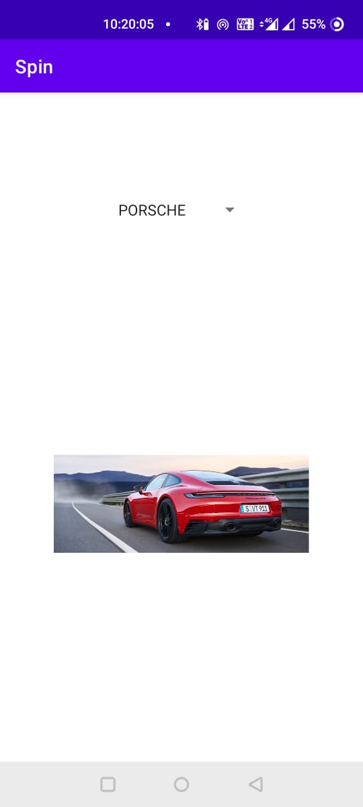 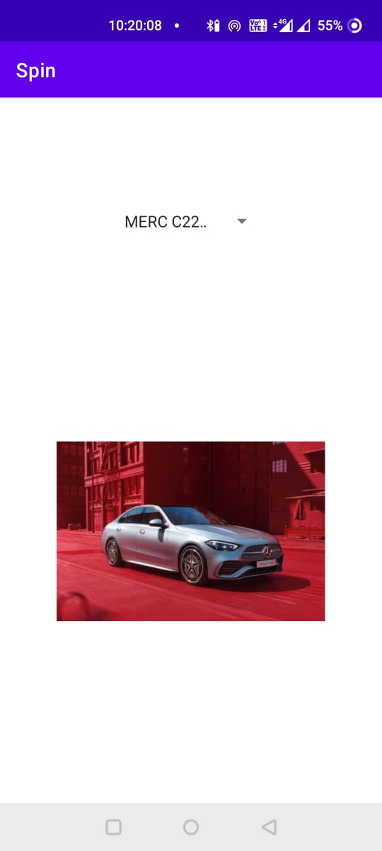

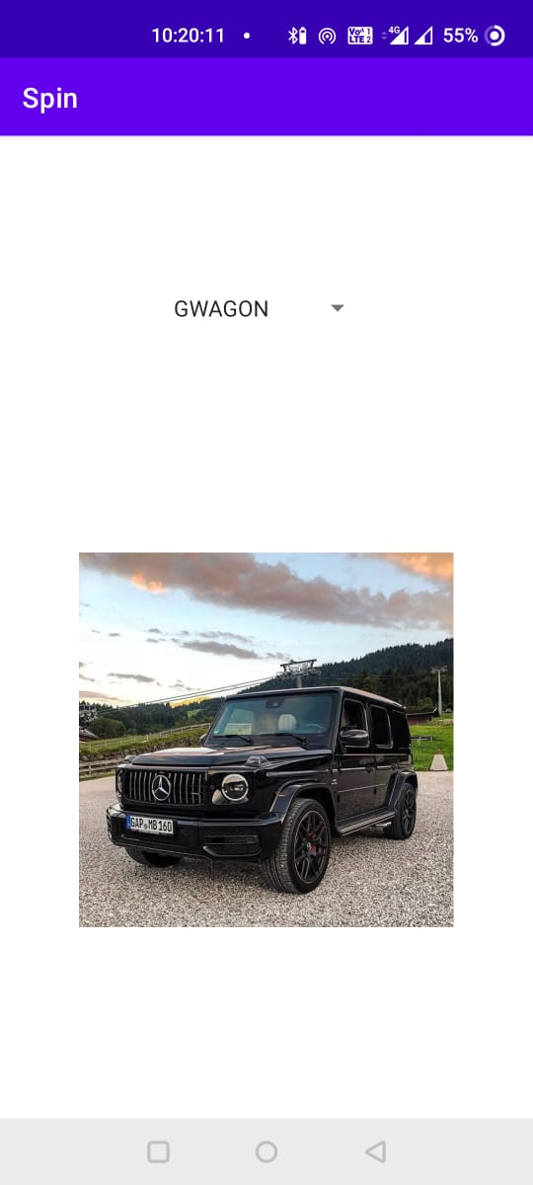

**Conclusion:**

Hence, by completing this experiment I came to know that how to Create spinner with strings from the resource folder (res >> value folder). On changing spinner value, change image.

|  |  |  |  |
| --- | --- | --- | --- |
| **Writeup & Oral**  **(4)** | **Practical Performance**  **(4)** | **Attendance**  **(2)** | **Total**  **(10)** |
|  |  |  |  |